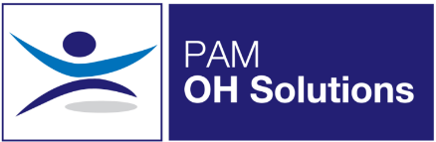
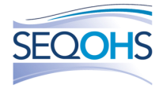
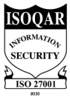
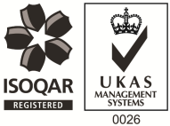
Occupational Health Advisor
PAM OH Solutions provides occupational health and HR services to a range of multi-national clients in the private sector and public sector organisations. Since the launch the business has built a strong portfolio of clients throughout the UK and has a comprehensive range of qualified staff based regionally in order to maintain its growth. We are now looking for an Occupational Health Advisor to join our team in Bristol. The role will be a mix between remote working and at our client sites in Bath & Bristol.
Our Values:
At PAM we are passionate about delivering our Everyday Things That Matter Values & Behaviours to our customers and our colleagues, PAM recognises that the successful delivery of its values is through its people. We’re looking for driven and ambitious professionals to join our team, who are just as passionate about our values as we are:
- Hard Work & Enthusiasm – We believe hard work should be rewarded and we appreciate employees who go that extra mile to achieve their goals. Enthusiasm to us, comes from within, and shows a real passion for what we do.
- Teamwork & Friendship – We want all of our colleagues to have a feeling of belonging, and we understand that collaborative working means better decisions making and supporting one another to achieve common goals.
- Loyalty & Improvement – PAM Group are committed to its employees and dedicated to their personal and professional development. PAM Academy mentors’ colleagues and provides support to help them be the best they can be every day.
What We Can Offer You:
We have a fabulous benefits package available to all staff.
- Excellent Pension Plan – we pay your 8% auto-enrolment and up to 5% matched contribution
- Industry-leading Health Scheme – Opticians, Dental, Physio & more!
- 24/7 Doctor helpline – book a telephone or video appointment with a GP
- Employee Assistance Program – 24/7 telephone counselling helpline
- Life Insurance Scheme – 4 x your annual salary
- 33 Days Leave Including Bank Holidays, pro-rata for part-time hours
- NMC registration fees paid
- Support with CPD & flexible working hours
- Training and Development opportunities
The Role:
Due to a period of continuous business growth, we’re now looking for Occupational Health Advisors to join the team! We have opportunities available for Occupational Health Advisors to undertake remote case management from home, whilst still having the option for occasional face to face appointments.
We can offer flexible working, with full or part time roles available as well as various shifts patterns, as we understand you need to make time for the important things in life!

