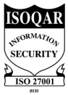
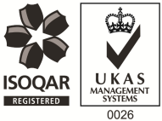

Commercial Administrator – 4 month FTC
Warrington
About Us:
PAM Group, one of the leading Occupational Health & Wellbeing providers in the UK, offers its own ergonomic workplace solutions service, PAM Health.
PAM Health supply a wide range of solutions for working arrangements with Display Screen Technology. The perfect modern-day office will encompass Screen Mounting Solutions, Height Adjustable Workstations for Sitting and Standing, Ergonomic Desktop and Under-desk Accessories plus Ergonomic Workchairs and Task Seating for the most demanding environments.
An exciting opportunity has arisen with PAM Health as a Commercial Administrator to work closely with our General Manager and ensure the best service possible for our clients,
About the Role:

- Speaking with customers via telephone and email to provide ongoing support and good customer service.
- Responsible for enquiries relating to existing accounts and ensuring these are dealt with on a daily basis and account requests are acted upon.
- Processing customer orders and enquiries
- Communicating with the sales department, wider PAM Group team and customers via telephone and by email
- Processing customer orders and managing the purchase order process
- Managing stock records and maintain up t date sales reports

About You:

- Excellent communication skills & IT Literate
- Previous experience with Sage 200 & Microsoft packages
- Strong administration skills
- Ability to work autonomously as well a key team player

Apply now!

