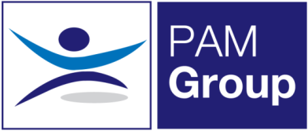
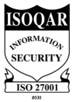
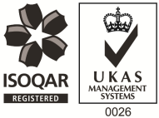
Occupation Health Auditor
Homebased and Client Site
Full Time/Part Time/Job Share - Excellent Salary and Benefits Package
PAM Occupational Health Solutions provides occupational health and HR services to an exceptional portfolio of multi-national clients in the public and private sectors. Our Services are delivered by a comprehensive range of qualified Occupational Health practitioners, based across the UK. We are growing our expert teams through flexible roles and homebased opportunities.
The Role
A fantastic new opportunity has arisen within PAM Occupational Health Solutions and PAM Academy for a Occupational Health Auditor. The key aspect for the role will involve auditing management referrals, health surveillance and medicals remotely to ensure they are accurate and reach the standard expected by our clients
You will liaise with PAM Academy, Clinical lead and senior management to ensure that the audit tools are appropriate, training needs are identified and ways of working can be improved.

Key Accountabilities
- Assess the quality of reports provided to management
- Audit the Auditor for those who are auditing the reports
- Assess the quality of clinical notes written by clinicians
- Audit management referals and assessment documentation and outcomes
- Support the regional teams with specific auditing needs
- Report on trends and outcomes
- Support with directing any training needs
About You:
- Registered General Nurse
- Hold a valid NMC Pin
- Hold an Occupational Health Qualification, either certificate, degree or diploma
- Have experience of working with an Occupational Health role, preferably as a Senior Advisor
- Have experience in dealing with complex cases
- Effective Report Writing Skills
- Excellent Communication skills and the ability to liaise with senior stakeholders

What can we offer you?
We have a fabulous benefits package available to all staff.
- We pay your auto-enrolment pension contribution, so we pay your 5% contribution along with our 3% and you can also make enhanced contributions if you like.
- You will have a life insurance scheme valued at 4 x your annual salary
- 33 days annual leave including bank holidays, and you also have the option to sell a week of leave.
- Health Cash Plan Scheme, which covers you for things like Opticians, Dental Treatment and even Physio if needed!
- Access to a 24/7 EAP Counselling line and a 24/7 GP line along with some amazing discounts on things like food and drink, retail and days out, all through our rewards scheme.
- As a nurse we’ll also pay for your NMC registration and support you with your revalidation and CPD.

