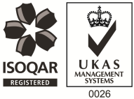
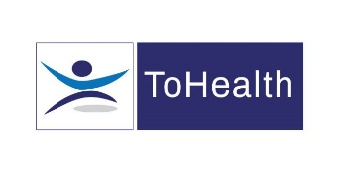
Occupational Health Advisor – Full Time
Excellent Salary and Benefits Package
4 Year Fixed Term Contract
We have an exciting role available for an Occupational Health Advisor working with a new client of ours. Whilst absence management will form part of this role, this isn’t a standard case management position. It will be full of variety including undertaking specialist medicals and delivering wellbeing and education sessions to members of staff. We’re looking for an enthusiastic OHA who is ready for new challenge.
You’ll be working as part of a wider OH team and reporting in to a Lead Occupational Health Advisor who will provide ongoing support and guidance. Our client has several sites including Southam, Milton Keynes & Aylesbury. You will need to have a valid UK drivers’ licence and access to a vehicle with suitable insurance. We’ll give you a car allowance and you’ll also get mileage contributions.
About You:
You’ll be a Registered General Nurse with a valid NMC pin number and hold a degree or diploma in Occupational Health. You will have previous experience in Occupational Health, preferably within the construction or infrastructure sectors.
What can we offer you?
We have a fabulous benefits package available to all staff.
- Pension Scheme – Auto Enrolment
- You will have a life insurance scheme valued at 4 x your annual salary
- 33 days annual leave including bank holidays, and you also have the option to sell a week of leave.
- Health Cash Plan Scheme, which covers you for things like Opticians, Dental Treatment and even Physio if needed!
- Access to a 24/7 EAP Counselling line and a 24/7 GP line along with some amazing discounts on things like food and drink, retail and days out, all through our rewards scheme.
- As a nurse we’ll also pay for your NMC registration and support you with your revalidation and CPD.
Roles like these don’t come up very often, Apply Now!

