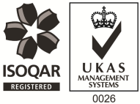
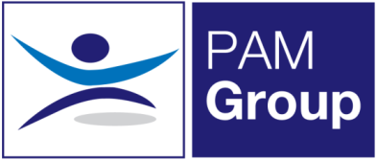

Occupational Health Screening Nurse – Full or Part-time

Excellent Salary & Benefits Package and Training and Development Opportunities

We have an exciting role available for an Occupational Health Nurse or an RGN looking to get into Occupational Health, to work with several of our established clients. This role will be based across multiple sites, so the post hold must have a driving license and relevant insurance. Sites include; Bath, Devizes, Swindon & Salisbury.

The post is working 3, 4 or 5 days per week Monday to Friday. You will provide Health Surveillance and Screening services to our public and private sector clients.

About You:
You’ll be a Registered General Nurse with a valid NMC pin number. You will ideally have previous experience in Occupational Health however this is not essential as training can be provided. As a minimum we would prefer you to be trained in Immunisations, Vaccinations and Phlebotomy. We can then provide further training if needed for other screening work such as Audio testing, Spirometry, Vision Testing and HAVS.

The benefits package includes:

- Pension Scheme - We pay your auto-enrolment pension at 8% total
- Health Scheme – Opticians, Dental, Physio & more!
- 24/7 Doctor helpline – book a Telephone or Video Appointment with a GP
- Employee Assistance Program – 24/7 telephone counselling helpline
- Life Insurance Scheme – 4 x your annual salary
- 33 Days Leave Including Bank Holidays, pro-rata for part-time hours
- NMC registration fees paid
- Support with CPD
- Training and Development opportunities

This is an exciting opportunity for an Occupational Health Nurse to develop their skills, or an enthusiastic RGN who is looking to move into an Occupational Health role – Apply Now!

