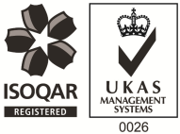
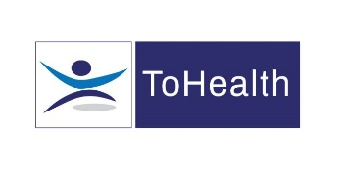

Occupational Health Nurse / Screening Nurse – Full Time
4 Year Fixed Term Contract
Excellent Salary & Benefits Package and Training and Development Opportunities

A new and exciting opportunity has arisen to work with a new client of ours. We are looking to employ experienced Occupational Health Nurses on a full-time basis to work with this new client on a fixed term contract. The role will involve covering multiple sites including Aylesbury, Milton Keynes and Southam. The postholder must be flexible to travel and have access to their own vehicle with suitable insurance.

Working as an Occupational Health Nurse will involve:
- Performing Routine, Pre-Placement and Wellbeing medicals
- Undertaking other medicals such as Safety Critical and Exit Medicals
- Undertaking general Health Surveillance including Audio, Vision and Lung Function screening
- Drug and alcohol screening
- HAVS Assessments
- Flu Vaccinations
- Attending weekly progress meetings with the Occupational Health Team
- Delivering Toolbox Talks, Education and Wellbeing sessions

The ideal candidate will have the following:

- You must be a Registered General Nurse and hold a valid NMC Pin
- Ideally have experience of working within an Occupational Health role, or have some health screening experience
- You must be First Aid and Defibrillator trained
- Ideally have experience within the Construction or Infrastructure sectors
- Excellent Communication skills

The benefits package includes:

- Pension Scheme
- Health Scheme – Opticians, Dental, Physio & more!
- 24/7 Doctor helpline – book a Telephone or Video Appointment with a GP
- Employee Assistance Program – 24/7 telephone counselling helpline
- Life Insurance Scheme – 4 x your annual salary
- 33 Days Leave Including Bank Holidays, pro-rata for part-time hours
- Car Allowance & Mileage Contributions
- NMC registration fees paid
- Support with CPD
- Training and Development opportunities

This role would suit someone currently working as an Occupational Health Nurse, Health Screening Nurse or Practice Nurse. Apply Now!

