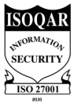
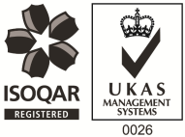
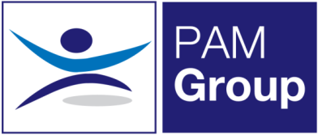

Occupational Health Nurse / Screening Nurse – Full Time
Leeds and Field Based
Excellent Salary & Benefits Package

PAM OH Solutions provides occupational health and HR services to an exceptional portfolio of multi-national clients in the public and private sectors. Our Services are delivered by a comprehensive range of qualified Occupational Health practitioners, based across the UK. We are growing our expert teams through flexible roles, homebased and field based opportunities
The Role
We have an exciting role available for Occupational Health Nurses or an RGN looking to get into Occupational Health, to work with several of our established clients. The role will predominantly be based from our Leeds Clinic with regular visits to client sites in surrounding areas.

About You;
You’ll be a Registered General Nurse with a valid NMC pin number. You will ideally have previous experience in Occupational Health however this is not essential as training can be provided. As a minimum we require you to be trained in Immunisations, Vaccinations and Phlebotomy. We can then provide further training if needed for other screening work such as Audio testing, Spirometry, Vision Testing and HAVS.
This is a full time role, working 40hrs Monday – Friday. You will provide Health Surveillance and Screening services to our public and private sector clients.

The benefits package includes:

- Pension Scheme - We pay your auto-enrolment pension at 8% total
- Health Scheme – Opticians, Dental, Physio & more!
- 24/7 Doctor helpline – book a Telephone or Video Appointment with a GP
- Employee Assistance Program – 24/7 telephone counselling helpline
- Life Insurance Scheme – 4 x your annual salary
- 33 Days Leave Including Bank Holidays, pro-rata for part-time hours
- NMC registration fees paid
- Support with CPD
- Training and Development opportunities

This is an exciting opportunity for an Occupational Health Nurse to develop their skills, or an enthusiastic RGN who is looking to move into an Occupational Health role – Apply Now!

