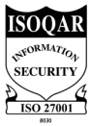
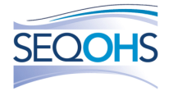
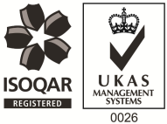
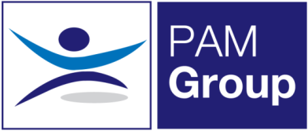

Home Based Occupational Health Advisor – Full or Part Time

Excellent Salary & Benefits Package
An opportunity has become available within PAM Group for an experienced Occupational Health Advisor to undertake remote case management from home. You will mainly be doing sickness and absence management appointments over the phone, but you’ll still get to do some face to face clinics occasionally within your local area.
The role is working 5 days per week but we can also offer 3 or 4 days per week if preferred. You’ll be working as part of a wider OH team and reporting in to a Lead Occupational Health Advisor who will provide ongoing support and guidance.
About You:
You’ll be a Registered General Nurse with a valid NMC pin number and hold a degree or diploma in Occupational Health. You will have previous experience in Occupational Health, preferably within the retail sector but this is not essential. You’ll have excellent case management skills and be competent at writing reports.
What can we offer you?
We have a fabulous benefits package available to all staff.
- We pay your auto-enrolment pension contribution, so we pay your 5% contribution along with our 3% and you can also make enhanced contributions if you like.
- You will have a life insurance scheme valued at 4 x your annual salary
- 33 days annual leave including bank holidays, and you also have the option to sell a week of leave.
- Health Cash Plan Scheme, which covers you for things like Opticians, Dental Treatment and even Physio if needed!
- Access to a 24/7 EAP Counselling line and a 24/7 GP line along with some amazing discounts on things like food and drink, retail and days out, all through our rewards scheme.
- As a nurse we’ll also pay for your NMC registration and support you with your revalidation and CPD.
Apply Now!

