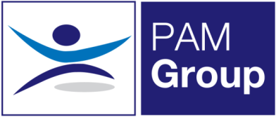
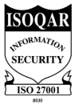
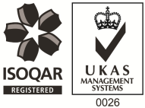
Clinical Lead Occupational Health Advisor
Full Time - Excellent Salary and Benefits Package
A new role has arisen with PAM OH Solutions for a Clinical Lead to work with some of our well-established clients, as well as getting involved with our new clients. The role will be predominantly home based, plus occasional travel to client’s sites within your local area.
About the Role:
- Managing a team of Occupational Health Advisors with regards to providing support, guidance and development for the PAM Ways of working. Including reviewing and auditing team members in order to foster development.
- Contribute towards safe working practices across the OH Delivery team and ensure Clinical Governance is adhered to by colleagues within your team.
- Conducts Health Assessments, reporting on the outcomes within agreed with PAM OH standards, policies and procedures and NMC guidelines.
- Manages Health Records ensuring safe storage, security and confidentiality of all OH records, at all times complying with relevant legislation and good practice.
- Produces management reports as required.
About You:
- Registered General Nurse
- Hold a valid NMC Pin
- Hold an Occupational Health Qualification, either certificate, degree or diploma
- Have experience of working with an Occupational Health role, preferably as a Senior Advisor
- Have experience in dealing with complex cases
- Effective Report Writing Skills
- Excellent Communication skills

What can we offer you?
We have a fabulous benefits package available to all staff.
- We pay your auto-enrolment pension contribution, so we pay your 5% contribution along with our 3% and you can also make enhanced contributions if you like.
- You will have a life insurance scheme valued at 4 x your annual salary
- 33 days annual leave including bank holidays, and you also have the option to sell a week of leave.
- Health Cash Plan Scheme, which covers you for things like Opticians, Dental Treatment and even Physio if needed!
- Access to a 24/7 EAP Counselling line and a 24/7 GP line along with some amazing discounts on things like food and drink, retail and days out, all through our rewards scheme.
- As a nurse we’ll also pay for your NMC registration and support you with your revalidation and CPD.

