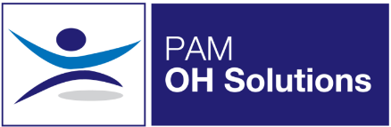
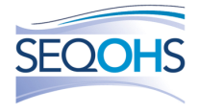
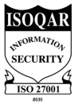
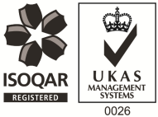
Occupational Health Technician
Client Site Based (Aylesbury & Bicester)
Full Time - Excellent Salary and Benefits Package
PAM Occupational Health Solutions provides occupational health and HR services to an exceptional portfolio of multi-national clients in the public and private sectors. Our Services are delivered by a comprehensive range of qualified Occupational Health practitioners, based across the UK. We are growing our expert teams through flexible roles, Clinic, Field and homebased opportunities.

The Role
A fantastic opportunity has new arisen within PAM Occupational Health Solutions for a proven Occupational Health Technicians to join our team, and to continue the delivery of high quality services to one of our high profile clients. The role will consist of onsite clinic-based work with as a team of two with an Occupational Health Technician, however the wider OH team to which this role will be part of, includes OH Advisers, OH Nurses, OH Physician, Physiotherapists, Occupational Hygienists and a Wellbeing Adviser
There has never been a more important time to work in health and wellbeing and here at PAM we know the importance of looking after our people as well as our clients employees. This is a unique opportunity to be part of a team where we and our client take a holistic view of employee health & wellbeing. PAM appreciates the need to ongoing training & development and have ensured that the role incorporates such activities on a regular basis.

About the Role:

Various medical assessment & screening will be undertaken and the OHT will be expected to be able to undertake the necessary tests within each type of assessment, Examples of assessment /screening undertaken includes:-

- Pre-employment Health Screening
- Medical examination for screening purposes e.g blood pressure, eye tests, urine sample, BMI and lifestyle assessment
- Drug and alcohol screening
- Audiometric screening
- Lung function screening
- Vision screening

About You:

- Experience in an Occupational Health technician role or have relevant skills
- Excellent Communication skills
- A full driving license, access to a vehicle and flexibility to cover other sites as necessary
The Benefits:

- Pension Scheme
- Health Scheme – Opticians, Dental, Physio & more!
- 24/7 Doctor helpline – book a Telephone or Video Appointment with a GP
- Employee Assistance Program – 24/7 telephone counselling helpline
- Life Insurance Scheme – 4 x your annual salary
- 33 Days Leave Including Bank Holidays, pro-rata for part-time hours
- Training and Development opportunities

If you feel this role would be suitable for you – apply now!

