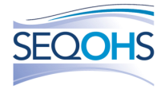
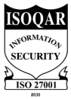
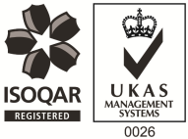
Occupational Health Advisor – Full or Part Time
The Role:
There has never been a more important time to work in health and wellbeing and here at PAM we know the importance of looking after our people as well as our clients ‘employees. In these roles you’ll be working with public & private sector clients, playing a critical role in supporting the health and wellbeing of their employees through management referrals; using your expert skills to help support and help people at work. This role is homebased, with occasional travel into Cambridge when COVID-19 restrictions ease.
About PAM:
At PAM we are passionate about people and delivering our Everyday Things That Matter Values and Behaviours to our customers and our colleagues. Our cultural philosophy is based on putting our people first, creating high performing teams who deliver great services for our clients.
We’re looking for driven and ambitious professionals to join our team, who are just as passionate about our philosophy and values as we are:
- Hard Work & Enthusiasm; we believe hard work should be rewarded, we go the extra mile to achieve our goas and support each other and enthusiasm and passion are part of our DNA
- Teamwork & Friendship; our colleagues share a sense of belonging; we understand collaborative working means better decisions making and we support each other to achieve common goals.
- Loyalty & Improvement; we are dedicated to personal and professional development. Our PAM Academy mentors’ colleagues and provides support to help you be the best you can through offering a wide range of CPD opportunities.

What We Can Offer You:
- Excellent Pension Plan – we pay your 8% auto-enrolment and up to 5% matched contribution
- Industry-leading Health Scheme – Opticians, Dental, Physio & more!
- 24/7 Doctor helpline – book a telephone or video appointment with a GP
- Employee Assistance Program – 24/7 telephone counselling helpline
- Life Insurance Scheme – 4 x your annual salary
- 33 Days Leave Including Bank Holidays, pro-rata for part-time hours
- NMC registration fees paid
- Support with CPD – Our PAM Academy team are committed to helping you achieve your career goals
- Training and Development opportunities

Next Steps:
We know how important choosing your next employer is and when you are ready to move you want to move quickly. In some roles we are able to offer an immediate start. Get in touch with our recruitment team now for more information.

