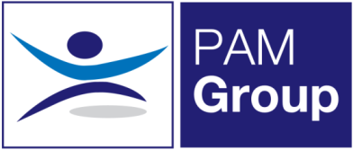
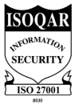
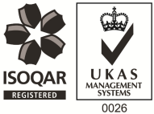
Clinical Lead Occupational Health
North East – Homebased and Clinic
Full Time - Excellent Salary and Benefits Package
PAM Occupational Health Solutions provides occupational health and HR services to an exceptional portfolio of multi-national clients in the public and private sectors. Our Services are delivered by a comprehensive range of qualified Occupational Health practitioners, based across the UK. We are growing our expert teams through flexible roles and homebased opportunities.
The Role
A fantastic opportunity has new arisen within PAM Occupational Health Solutions for a proven Clinical Lead to lead a team of Occupational Health Advisors, Screening nurses and Associates in supporting some of our well-established clients. There has never been a more important time to work in health and wellbeing and here at PAM we know the importance of looking after our people as well as our clients employees. In these roles you’ll be working with leading UK Organisations, playing a critical role in supporting the health and wellbeing of their employees through management referrals.
The role will involve a mixture of homeworking, client visits and on site in our Newcastle Clinic.
About the Role:
- Managing a team of Occupational Health Advisors, Screening nurses, Associates and Occupational Health Technicians in providing support, guidance and development for the PAM Ways of working. Including reviewing and auditing team members in order to foster development.
- Developing and mentoring the team through coaching and clinical support
- Being the senior clinical lead – be able to advise on complex cases and how to manage or where to escalate
- Monthly reviews of management reports for employed staff, coaching for improvement where necessary
- Contribute towards safe working practices across the Occupational Health Delivery team and ensure Clinical Governance is adhered to by colleagues within your team.
- Conducts Health Assessments, reporting on the outcomes within agreed with PAM Occupational Health standards, policies and procedures and NMC guidelines.
- Manages Health Records ensuring safe storage, security and confidentiality of all Occupational Health records, at all times complying with relevant legislation and good practice.
- Produces management reports as required.
About You:
- Registered General Nurse
- Hold a valid NMC Pin
- Hold an Occupational Health Qualification, either certificate, degree or diploma
- Have experience of working with an Occupational Health role, preferably as a Senior Advisor
- Have experience in dealing with complex cases
- Effective Report Writing Skills
- Excellent Communication skills

What can we offer you?
We have a fabulous benefits package available to all staff.
- We pay your auto-enrolment pension contribution, so we pay your 5% contribution along with our 3% and you can also make enhanced contributions if you like.
- You will have a life insurance scheme valued at 4 x your annual salary
- 33 days annual leave including bank holidays, and you also have the option to sell a week of leave.
- Health Cash Plan Scheme, which covers you for things like Opticians, Dental Treatment and even Physio if needed!
- Access to a 24/7 EAP Counselling line and a 24/7 GP line along with some amazing discounts on things like food and drink, retail and days out, all through our rewards scheme.
- As a nurse we’ll also pay for your NMC registration and support you with your revalidation and CPD.

