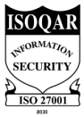
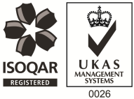
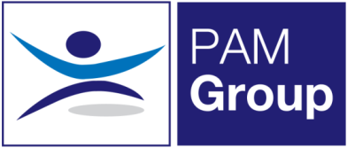

Occupational Health Advisor – Full or Part Time

Competitive Salary & Excellent Benefits Package
PAM OH Solutions is looking to employ an experienced Occupational Health Advisor to provide services from home and from our client’s premises in Brackmills and Kempton. You will cover 4 clinics per month at these locations, the rest of your time will be spent working from home undertaking telephone consultations. The role is working a minimum of 3 days per week but we can also offer 4 or 5 days per week if preferred
The successful candidate will be responsible for pro-active Sickness Absence Management of short and long term absence cases, both face to face and via telephone consultations.
The role will involve:
- Advising on phased return to work programmes.
- Conducting Health Assessments, reporting on the outcomes within agreed timescales and to PAM OH standards, policies and procedures and NMC guidelines.
- Managing Health Records ensuring safe storage, security and confidentiality of all OH records, at all times complying with relevant legislation and good practice.
- Producing management reports as required.
- Actively promotes fitness for work, both preventative and rehabilitative, raising the profile of OH amongst all levels of employees and management.
- Supporting the Businesses in reducing absence and improving their people potential at all times.
- Providing clear pragmatic advice to clients and employees that adds value to their decision making
- Seeking continuous improvement in the service provided, identifying opportunities to develop the function and proposing improvements and suggestions for continuous improvement.
- Attending meetings with client HR and Health and Safety teams

The ideal candidate will have the following:

- You must be a Registered General Nurse
- Hold a valid NMC Pin
- Hold or be working towards an Occupational Health Qualification, either certificate, degree or diploma
- Have experience of working with an Occupational Health role
- Effective Report Writing Skills
- Excellent Communication skills

The benefits package includes:

- Pension Scheme
- Health Scheme
- Life Insurance Scheme
- 33 Days Leave Including Bank Holidays, pro-rata for part-time work
- Business Mileage
- NMC Registration

If you feel this vacancy would be suitable for you – apply now!

