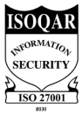
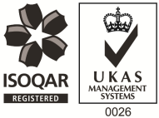
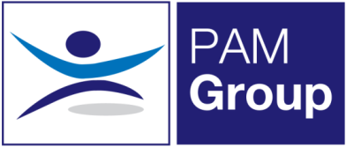

Occupational Health Advisor – Full or Part-Time

Competitive Salary + Car Allowance - Competitive Benefits Package
PAM OH Solutions is looking to employ an experienced Occupational Health Advisor to provide services at our clinic in Milton Keynes. You will be based at our clinic at Kiln Farm 2 days per week, the role will require you to cover 1 day per week at a client’s site in Brackley. Further work could be provided for anyone looking to work full time.
The post will be working on a full or part-time basis and you will provide Occupational Health services and support at our client’s sites. The successful candidate will be responsible for the full remit of Occupational Health, including pro-active Sickness Absence Management of short- and long-term absence cases and Health Surveillance.
The role will involve:
- Advising on phased return to work programmes.
- Conducting Health Assessments, reporting on the outcomes within agreed timescales and to PAM OH standards, policies and procedures and NMC guidelines.
- Managing Health Records ensuring safe storage, security and confidentiality of all OH records, at all times complying with relevant legislation and good practice.
- Produces management reports as required.
- Actively promoting fitness for work, both preventative and rehabilitative, raising the profile of OH amongst all levels of employees and management.
- Supporting the Businesses in reducing absence and improving their people potential at all times.
- Providing clear pragmatic advice to clients and employees that adds value to their decision making
- Seeking continuous improvement in the service provided, identifying opportunities to develop the function and proposing improvements and suggestions for continuous improvement.
- Undertaking health surveillance including Audiometry, Spirometry and Vision Testing

The ideal candidate will have the following:

- You must be a Registered General Nurse
- Hold a valid NMC Pin
- Hold or be working towards an Occupational Health Qualification, either certificate, degree or diploma
- Have experience of working with an Occupational Health role
- Effective Report Writing Skills
- Excellent Communication skills

The benefits package includes:

- Pension Scheme
- Health Scheme
- Life Insurance Scheme
- 33 Days Leave Including Bank Holidays, pro-rata for part-time work
- Mileage Contributions
- NMC Registration

If you feel this vacancy would be suitable for you – apply now!

