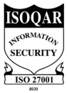
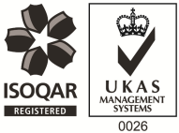
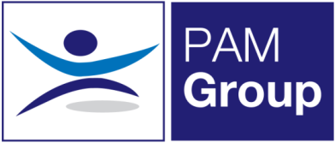

Home Based Occupational Health Advisor –Part Time

Excellent Salary & Benefits Package
PAM Group is looking to employ an experienced Occupational Health Advisor to undertake remote case management from home. The role is working 3 days per week but we can also offer 4 or 5 days per week if preferred. Whilst this role is predominantly home based, we are looking for someone who is willing to cover a few on site clinics per month in surrounding areas in Kent when needed.
The successful candidate will be responsible for pro-active Sickness Absence Management of short- and long-term absence cases, both face to face and via telephone consultations.
The role will involve:
- Advising on phased return to work programmes.
- Conducting Health Assessments, reporting on the outcomes within agreed timescales and to PAM OH standards, policies and procedures and NMC guidelines.
- Managing Health Records ensuring safe storage, security and confidentiality of all OH records, at all times complying with relevant legislation and good practice.
- Producing management reports as required.
- Actively promotes fitness for work, both preventative and rehabilitative, raising the profile of OH amongst all levels of employees and management.
- Supporting the Businesses in reducing absence and improving their people potential at all times.
- Providing clear pragmatic advice to clients and employees that adds value to their decision making
- Seeking continuous improvement in the service provided, identifying opportunities to develop the function and proposing improvements and suggestions for continuous improvement.
- Attending meetings with client HR and Health and Safety teams

The ideal candidate will have the following:

- You must be a Registered General Nurse
- Hold a valid NMC Pin
- Hold or be working towards an Occupational Health Qualification, either certificate, degree or diploma
- Have experience of working with an Occupational Health role
- Effective Report Writing Skills
- Excellent Communication skills

The benefits package includes:

- Pension Scheme - We pay your auto-enrolment pension at 8% total
- Health Scheme – Opticians, Dental, Physio & more!
- 24/7 Doctor helpline – book a Telephone or Video Appointment with a GP
- Employee Assistance Program – 24/7 telephone counselling helpline
- Life Insurance Scheme – 4 x your annual salary
- 33 Days Leave Including Bank Holidays, pro-rata for part-time hours
- Mileage Contributions
- NMC registration fees paid
- Support with CPD
- Training and Development opportunities

This role would suit an experienced Occupational Health Advisor looking to be mainly home based. If you feel this vacancy would be suitable for you – apply now!

