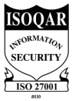
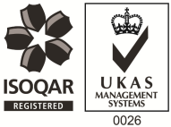
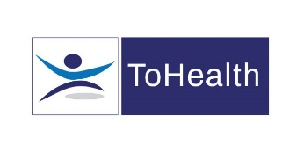

Occupational Health Advisor – Full or Part-Time – 4 Year Fixed Term Contract

Excellent Salary & Competitive Benefits Package
ToHealth is a subsidiary of PAM Group Ltd, we are highly experienced Occupational Health and Wellbeing specialist, providing services to employees across the UK in both the public and private sector. We are expanding and so are now looking to employ experienced Occupational Health Advisors on a full or part-time basis to work with one of our clients on a fixed term contract. The role will involve covering multiple sites including Buckingham, Banbury, Wendover, Aylesbury, Brackley, Milton Keynes and Southam. The postholder must be flexible to travel and have access to their own vehicle with suitable insurance.

Main Responsibilities:
- Undertaking sickness absence management appointments and producing management reports as required
- Advising on phased return to work programmes
- Actively promoting fitness for work, both preventative and rehabilitative, raising the profile of OH amongst all levels of employees and management
- Supporting the client in reducing absence and improving their people potential at all times.
- Undertaking Health Surveillance
- Delivering Toolbox talks, education and wellbeing sessions
- Attend weekly progress meetings
- Undertaking Routine, pre placement and wellbeing medicals
- Conducting regular site tours
- Managing Health Records ensuring safe storage, security and confidentiality of all OH records, at all times complying with relevant legislation and good practice

The ideal candidate will have the following:

- You must be a Registered General Nurse and hold a valid NMC Pin Number
- Hold or be working towards an Occupational Health Qualification, either certificate, degree or diploma
- You must be First Aid and Defibrillator trained
- Have experience of working with an Occupational Health role, preferably as an advisor
- Ideally have experience in the Infrastructure or Construction sectors
- Effective Report Writing Skills
- Excellent Communication skills

The benefits package includes:

- Pension Scheme
- Health Scheme – Opticians, Dental, Physio & more!
- 24/7 Doctor helpline – book a Telephone or Video Appointment with a GP
- Employee Assistance Program – 24/7 telephone counselling helpline
- Life Insurance Scheme – 4 x your annual salary
- 33 Days Leave Including Bank Holidays, pro-rata for part-time hours
- NMC registration fees paid
- Support with CPD
- Training and Development opportunities

This role would suit someone currently working as an Occupational Health Advisor, apply now!

