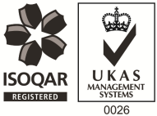
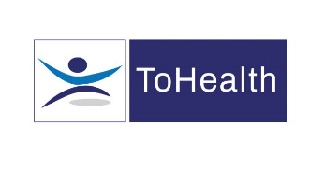
Occupational Health Advisor – Full or Part Time
Excellent Salary and Benefits Package
We have an exciting role available for an Occupational Health Advisor working with several of our established clients. This role will mainly focus on case management but it will also involve health surveillance such as medicals. The role will involve working with one of our clients on site in Merton once per week and also working from our clinics in London which are in Catford, Liverpool Street and St Pancras Hospital. The post holder must be flexible to travel as this role covers multiple sites. We will also be able to offer some home working.
You’ll be working as part of a wider OH team and reporting in to a Lead Occupational Health Advisor who will provide ongoing support and guidance.
About You;
You’ll be a Registered General Nurse with a valid NMC pin number and hold a degree or diploma in Occupational Health. You will have previous experience in Occupational Health with good case management and report writing skills.
What can we offer you?
We have a fabulous benefits package available to all staff.
- We pay your auto-enrolment pension contribution, so we pay your 5% contribution along with our 3% and you can also make enhanced contributions if you like.
- You will have a life insurance scheme valued at 4 x your annual salary
- 33 days annual leave including bank holidays, and you also have the option to sell a week of leave.
- Health Cash Plan Scheme, which covers you for things like Opticians, Dental Treatment and even Physio if needed!
- Access to a 24/7 EAP Counselling line and a 24/7 GP line along with some amazing discounts on things like food and drink, retail and days out, all through our rewards scheme.
- As a nurse we’ll also pay for your NMC registration and support you with your revalidation and CPD.
Roles like these don’t come up very often, Apply Now!

