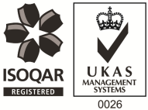
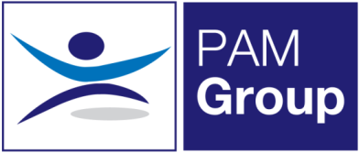

MSK Physiotherapist – Southampton - 3 Days per week

PAM Group is a highly experienced Occupational Health and Wellbeing specialist, providing services to more than 450,000 employees across the UK in both the public and private sector. We have over 10 years’ experience, working with clients to reduce absence and promote health and wellbeing in the workplace. We provide a wide range of services including Physiotherapy and Rehabilitation Services, Case Management, Psychological Return to Work Services, Wellbeing Services FCE’s as well as Job Task Analysis.
Due to significant business growth, we are currently looking to employ a musculoskeletal Physiotherapist to join our team in Southampton on a part-time basis 3 days per week. The role will be working from the Southampton clinic one day a week and also travel to surrounding areas to undertake DSE assessments.
As a growing organisation this is an exciting time within the business with excellent opportunities to develop your role specific skills and for those joining us.
The role will involve:
- Working as an autonomous MSK practitioner, managing a range of musculoskeletal conditions in an outpatient setting
- Delivering a thorough and detailed MSK assessment, using appropriate clinical techniques and equipment.
- Using clinical reasoning to diagnose patient problems.
- Delivering evidence-based intervention / treatment to all patients, in line with CSP, and NICE guidelines, and in accordance with the PAM Wellbeing Treatment pathway.
- Delivering tailored, progressive, individualised physiotherapy treatment programmes and group exercise/education programmes using clinical assessment and reasoning skills.
- Formulating treatment plans / goals, assisting and enabling patients to achieve their treatment goals and targets.
- Providing appropriate advice based on the patient’s medical, social and cultural circumstances.
- Maintaining accurate, comprehensive, contemporaneous patient records in line with CSP standards of practice.
- Recording the information in line with clients SLA’s and CSP guidelines.
- Providing hands on physiotherapy interventions and assessment.
- Liaising with employee managers to provide reports, treatment updates, and return to work / task modification recommendations

The post holder will ideally have the following:
- A keen interest in MSK physiotherapy
- CSP Registered
- HCPC Registered
- Have previous experience in an OH setting desirable but not essential as training provided
- Effective Communication skills

The Company fully believes in supporting its staff members, and has supported a number of employees through further development courses. PAM Wellbeing also offers an excellent benefits package including:
- Support with CPD and registration fees
- Pension Scheme
- Health Scheme
- Life Insurance Scheme
- 33 Days Leave Including Bank Holidays, pro-rata for part-time hours
- Car & Mileage allowance

If you feel you would be suitable for this role, apply now!

